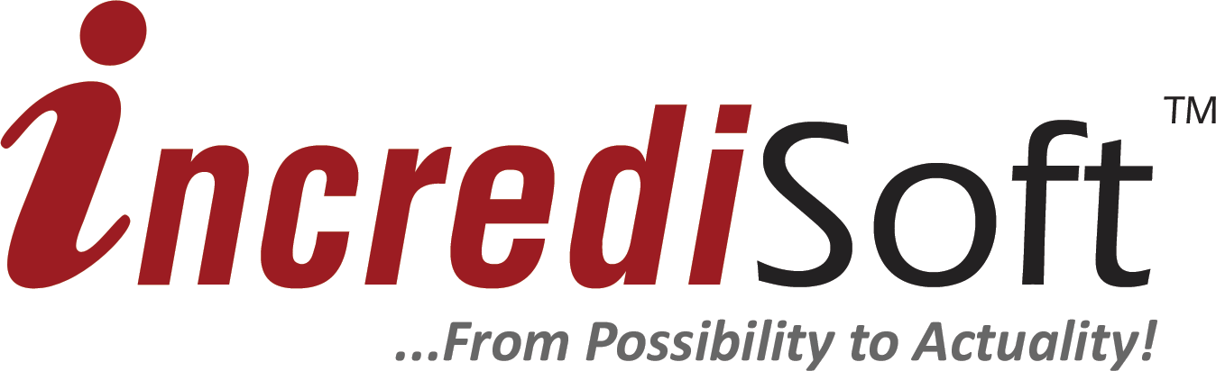

Project: iLearn
Student Information System

Prepared for: Mr. Carlos Chan
Principal
Toledo Community College

Prepared by: Chris Aguilar
Maurice Rogers

Description:

An application designed to streamline the school's student management operations.

Introduction

Project Acceptance...
The Toledo Community College has decided to introduce a formal, electronic, consistent standard for the management of student information. This information includes personal data, grades received and student progression.

The Goals...
The Toledo Community College has decided to contract the services of IncrediSoft to develop and implement a scalable, dependable and secure student information system. The goals of this system are:

- To streamline the way the school carries out its daily student operations.
- Record and collect information on students and their progress.
- To provide a simple, straight forward way to produce recurrent documents relating to student performance i.e. report cards and transcripts.

The Solution...

IncrediSoft is a Belizean owned Information and Communication Technology firm specializing in customized software applications and website design. With experience in creating software applications for organizations and businesses ranging from small offices to enterprise wide systems.

- We will create the software needed to capture all relevant student information.
- The software, when used properly, will greatly increase worker productivity offer greater transparency in school operations.
- The software will facilitate for fast, efficient reporting.

Production Schedule

The following is our projected production schedule for the project. The projected project schedule is expected to take approximately 14 – 16 weeks of calendar time. The schedule allows time for gathering data, designing the software properly, multiple rounds of proofs, testing and change requests.

- Proposal acceptance: Thursday, February 3rd 2011
- Assign project team: Thursday, February 10th 2011
- Design process begins: Thursday, February 10th 2011
- All client supplied materials due: Monday, February 28th 2011
- Start project development: Tuesday, March 1st 2011
  - Project planning complete: Friday, March 11th 2011
  - Project design complete:
  - Project Alpha completion:
  - Project Alpha testing completion:
  - First draft delivery for client proofing:
- Project Beta completion:
- Project Beta testing completion:
- Project Final Completion:
- Client approval on Final Release:
- Final testing completion:
- Software and user manual delivered to department representative on
- Software installed and configured on all specified computers:
- Training completion:
- Project Fully operational:
Project Deliverables

The following is a complete list of all software requirement deliverables.

- Student Information
  - Personal
    - Name
    - Estimated Grad. Date
    - Gender
    - Ethnicity
    - Common Name
    - Birthdate
    - Primary Language
    - Email
    - Phone
    - Photo
  - Contact Information
  - Student's Home Address
  - Student's Mailing Address
  - Parent / Guardian Contact
  - Primary Emergency Contact
  - Secondary Emergency Contact
  - Medical Information
    - Primary Care Physician
    - Physician's Phone
    - Preferred Medical Facility
- Class
  - Class Name
  - # of Students
  - Subject
    - Instructor
    - Days and Time
      - Tests
      - Quizes
      - Assignments
      - Projects
      - Presentations
      - Exams
      - Other

